**January 30, 2015**

**Project 1: Fastener’s**

**2002 SV650S Suzuki**

**Mechanical Component: Cylinder Head Bolt**

**Team 4**

**Brian Wanezek- Leader**

**Stephen Walta- Chief of Staff**

**Brandon Tolbert- Integrator 1**

**Gatlin Arnold- Integrator 2**

**Adam Wagner- Integrator 3**

**Caleb Berryman- Integrator 4**

**Section 1.1 Project Definitions, Goals, Vehicle, and Component**

The goal of the project is to perform a complete fatigue analysis on a fastener and to learn more about the mechanics of the fastener in order to better understand the engineering that goes behind the design of this mechanical component. In this case, the fastener we chose is the cylinder block (or engine block) bolt on a 2002 SV650S Suzuki. The first objective is to research the physical properties of the fastener which include properties such as the dimensions, material, function, cost, and the manufacturing required for the component. Static analysis using general loading conditions will then be performed in order to calculate stresses in the component for fatigue analysis. Fatigue tests, failure criteria, and failure mechanisms will then be analyzed along with corresponding fatigue models. Using these models we will determine the life expectancy of the mechanical component based on the loading conditions previously used.

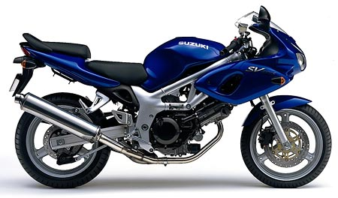

Figure 1 shows the side view of a 2002 SV650S Suzuki Motorcycle

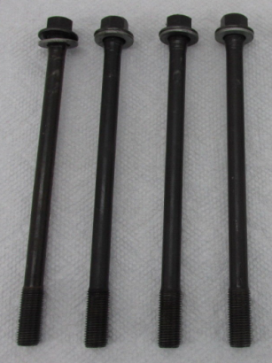

Figure 2 shows the engine block bolt

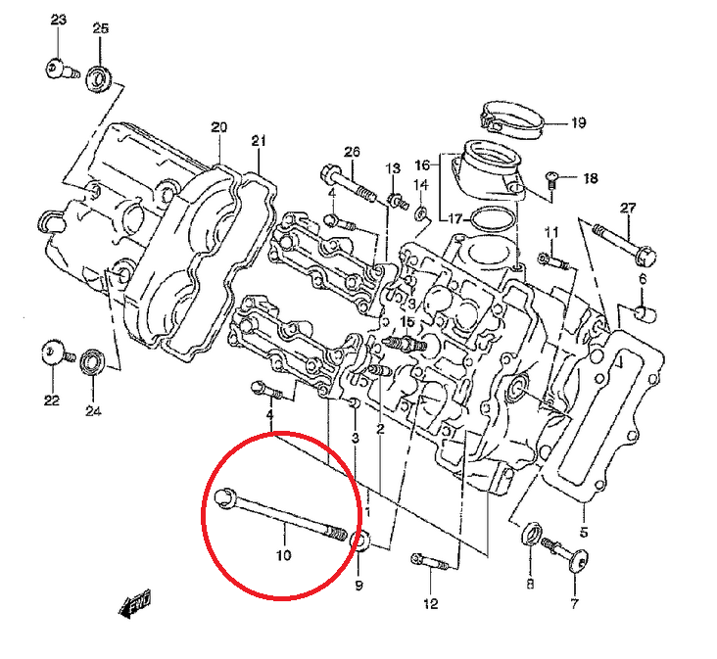

Figure 3 shows the cylinder block bolts’ placement in the motorcycle

[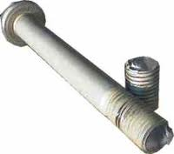](http://www.google.com/url?sa=i&rct=j&q=&esrc=s&source=images&cd=&cad=rja&uact=8&ved=0CAcQjRw&url=http://www.boltscience.com/pages/failure2.htm&ei=OEHLVLLyHIqWNpXZgDA&bvm=bv.84607526,d.eXY&psig=AFQjCNFXqDVRaZM7LHSOFrcbwwAr4VYelg&ust=1422692935258336)

Figure 4 shows a failed head bolt fastener [3]

**1.2 Utility, Technology, Safety Issues, Manufacturing and Economics**

The function of this bolt is to hold cylinder head to the cylinder block during the combustion process that occurs during the active use of the vehicle. The force that holds them together is created by applying a torque to the bolt head which causes the bolt to stretch. The elongation results in bolt tension (preload) which creates friction that holds the head and block together.

The bolt experiences a cyclic loading from the explosion in the combustion chamber in addition to the tensile forces created from pre-loading. The loads occurring within the bolt need to be analyzed to ensure the integrity of the bolts and that it will not fail when the engine is operating. A loss of tensile forces in the bolt could result in the loosening of the bolt under conditions of cyclic loading in addition to a reduction of the bolt’s fatigue life. In the event of a cylinder block bolt failing, the cylinder head will no longer have the required tension required to connect to the cylinder block, which in turn means the block cannot handle the force from combustion occurring in the combustion chamber. A non-functioning cylinder block will make the motorcycle inoperable.

The following Manufacturers design cylinder block bolts for our vehicle:

* Infasco
* Birmingham Fastener
* Portland Bolt & Manufacturing Company

The bolt is formed using cold forging by pressing a steel rod through various dies at high pressure. The rod is first straightened and then cut to the appropriate length. Then the rod segment goes through a series of dies that shape the hexagonal head. Next, the opposite end of the bolt is formed by chamfering the tip and then cold forging is used again with high pressure rollers to press in the pattern of the threads. Following the cold forging process, heat treatment is done to improve the overall hardness of the bolt material. The figure below demonstrates the cold forging process:

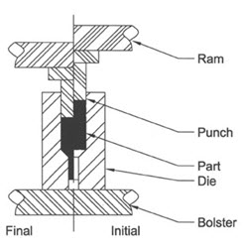

Figure 5 shows the scheme of the cold forging process [4]

During the cold forging process the metal is shaped to its desired geometry by using high pressure. The pressure pushes the ram down on the metal which forces the metal into a mold.

Purchasing the four required cylinder block for the 2002 SV650S costs $43.88 ($10.97 per bolt) from BikeBandit.com. This is the lower end of pricing for this specific bolt.

**Section 1.3 Dimensions, Materials, and Environmental Conditions**

The head bolts are 160mm long class 8.8 steel M10x1.5 bolts. The nominal diameter is 10mm while the pitch of the bolt is 1.5 threads per millimeter. The shank of the bolt matches the minor diameter of the threads giving it a uniform stress area along its length of 58mm2. All changes in cross section are large radius to reduce stress concentrations. The minimum yield strength is 640MPa and minimum tensile strength is 800MPa. The modulus of elasticity is 207GPa, the shear modulus is 79GPa, and the Poisson’s ratio is 0.29.

The bolt is entirely contained within the engine with the head under the valve cover so it is never exposed to any corrosive elements. The bolts are subjected to high block temperatures but so long as the cooling system is functioning, those remain well below 840F where temperature affects fatigue life.

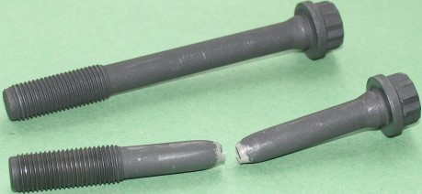

Figure 6 shows a failed head bolt next to an intact bolt [3]

**Section 1.4 General Loading Conditions**

The following Free Body Diagram shows the forces acting on the bolt:

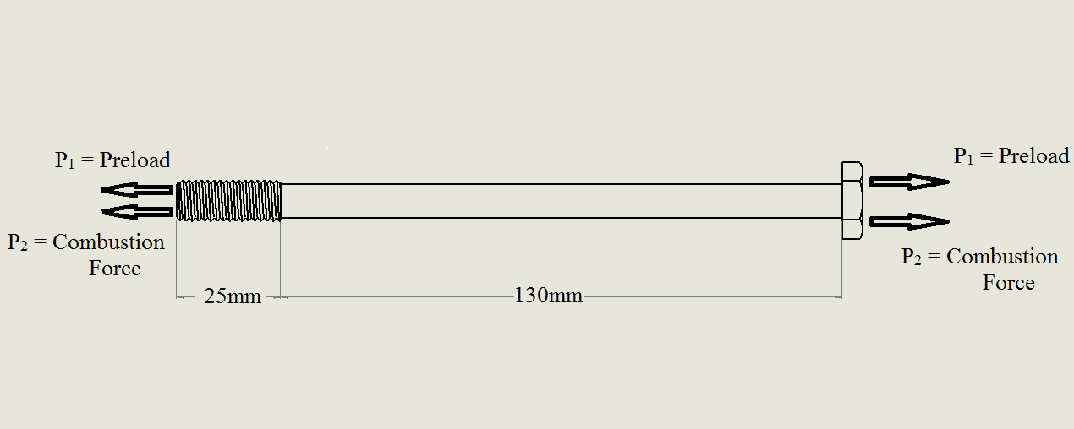

Figure 7 shows a free body diagram of the bolt under the general loading conditions

The bolt is exposed to a static load due to the preload put on the bolt after tightening and a dynamic load caused by the combustion process within the engine. The following equilibrium equations apply to the head bolt shown in **Figure 7** for the static load (preload)**:**

**(1)**

The following equilibrium equations apply to the dynamic case:

**(2)**

The preload force was determined with the following equation:

**(3)**

where

W= Clamping force

T= Torque

L= Lead

dm= nominal diameter

f= coefficient of friction

Cos(an)= bolt constant

dc= the collar diameter

fc= collar coefficient of friction

The 43Nm torque specification produces a clamping force of 21.8 KN which corresponds to an axial stress of 376 MPa. The dynamic stress was determined with the following equation:

**(4)**

where

Ac = the cross sectional area of the bolt

The six different loading conditions evaluated and the resulting operating points by engineer are shown in **Table 1** below:

|  |  |  |  |
| --- | --- | --- | --- |
| **TABLE 1.1: SHOWS THE LOADING CONDITIONS EVALUATED BY EACH ENGINEER** | | | |
| **Engineer** | **Cylinder Pressure, kPa** | **σm Stress** | **σAlt, Mpa** |
| Brian | 6900 | 452 | 77 |
| Adam | 5800 | 440 | 64 |
| Caleb | 4500 | 426 | 50 |
| Brandon | 4000 | 420 | 44 |
| Stepen | 3450 | 414 | 38 |
| Gatlin | 2720 | 406 | 30 |

The minimum loading condition was evaluated at a cylinder pressure of 2720 kPa which represents the engine at half throttle and 4000 rpm. The maximum loading condition was evaluated at a cylinder pressure of 6900 kPa which represents the engine at full throttle and 9000 rpm. The other loading conditions were evaluated between the maximum and minimum cylinder pressures.

Consider the maximum loading condition which represents the max throttle condition at 9000 rpm. At this condition, the cylinder goes through 5250 stress cycles per minute of operation. If the average person’s commute is 30 minutes each way for 5 days a week at 52 weeks per year, then running the engine at maximum produces 82 million stress cycles per year. Thus this component has to be well designed or it will not last very long.

**1.5 Fatigue Tests, Failure Criteria and Fatigue Failure Mechanisms**

The standard fatigue test is the rotating bending fatigue test performed by the R.R. rotating beam fatigue testing machine shown in the figure below:

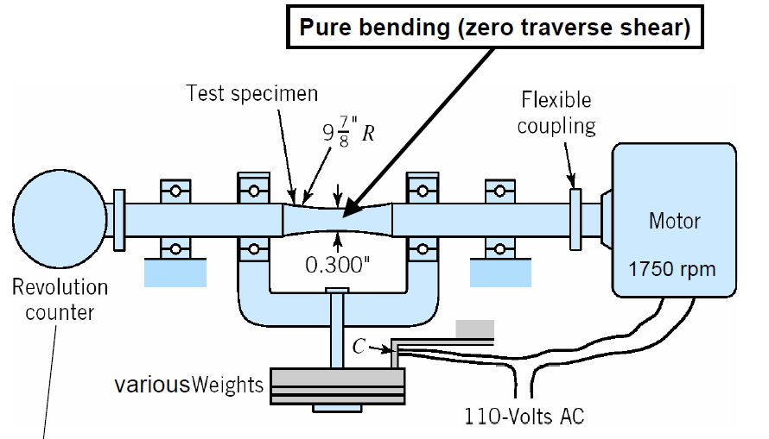

Figure 8 show the R.R. Moore Rotating beam fatigue testing machine [2]

Other fatigue-failure tests include reverse-bending, reverse axial load, and reverse torsional loading. Each test is carried out individually and results in different S-N diagrams. The best relevant fatigue test for this mechanical component would be reversed axial load. This specific test focuses the maximum stress across the entire cross section. In turn, the reversed axial loading gives endurance limits of about 10% less than the rotating bending fatigue test. If axial loading occurs even just slightly off the center, minute bending occurs which causes the stresses on one side to be a little more than the normal stress equation.

An S-N fatigue plot is an empirically derived plot from fatigue testing and is shown below:

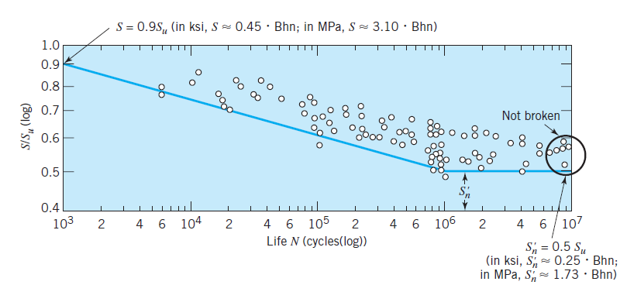

Figure 9 shows a generalized S-N curve for steel [2]

The curve demonstrates that a different loading conditions, there is a maximum number of oscillations the material can experience without failing. The transition from the linear decreasing line and the horizontal line in the figure indicates the endurance limit of the material, (S’n). This is also referred to as the knee. Any Loading below the endurance limit suggests that the material will never fail. From S-N diagrams fatigue plots can be developed based on the number of cycles such as 103 (L3), 104 (L4), 105 (L5), 106 (L6), etc. The below figures shows an S-N curve and the resulting fatigue plots for the Goodman model:

Figure 10 shows an empirically derived S-N curve

Figure 11 shows a constant life fatigue diagram based off the Goodman model

Usually a component has abstract geometries and exposed to different stresses other than tensile stresses, i.e. shear stresses. Up to our point in our materials science career, we have relied on Mohr’s circle to judge whether are component experienced failure or not. A more accurate representation of the real world is to apply the maximum-distortion-energy theory described by Von Mises. The equation is given below:

**(5)**

The Von Mises figure is shown below and derived from the above equation:

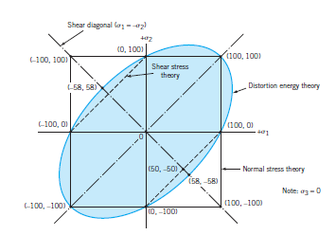

Figure 12 shows the Von Mises plot of distortion energy theory [2]

The Von Mises equation relates all acting loading conditions on a stress element (i.e. combined stresses, shear, and tensile) derived from Mohr’s circle and computes an equivalent tensile stress. This can be related to fatigue in S-N diagrams as well as ultimate tensile strength of a material to determine if failure will occur.

Biaxial loadings () may or may not cause failures due to which failure theory is being used. The Maximum normal stress theory shows that failure occurs when the greatest tensile or compressive stress is larger than the uniaxial tensile or compressive strength. With the maximum shear stress theory, the biaxial loading fails when maximum shear stress surpasses the yield shear strength. Due to the ductility of steel, the distortion energy theory would be the method to use for this mechanical component. Using the Von Mises figure, biaxial loading failure can be found on any point outside the ellipse.

Tri-axial loading failure is found by computing the equivalent stress then comparing it to “strength” in a uniaxial loaded bar. In the case of our mechanical component, there is no tri-axial loading.

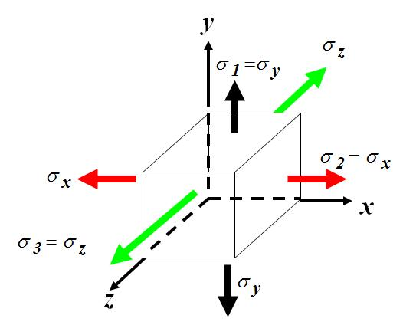

Figure 13 shows a generic stress element for triaxial loading stress analysis

Knowing what material the component is made of is necessary to use the best failure theory suited for the component. A ductile material is best suited for the maximum distortion energy theory. The Mohr theory is best suited for brittle materials. The ductile material of the component will distort until failure, while a brittle component would fracture with a clearly defined separation.

**1.6 Fatigue Models**

The relevant fatigue model in our analysis is the Gunn model. Researchers R.L Burguete and E.A. Patterson performed fatigue testing on a class of bolt heads. The failed specimen’s best correlated with the Gunn model as shown below in the Haigh diagram which plots the mean stress vs. alternating stress:

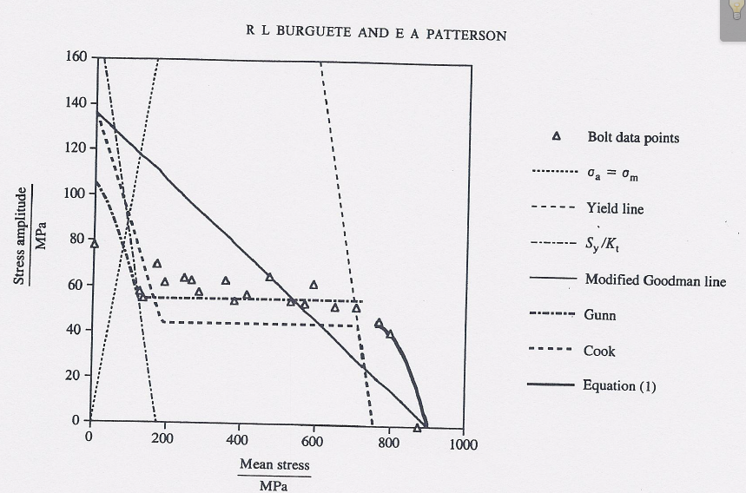

Figure 14 shows that the fatigue limit of high tensile bolts best correlate with the Gunn model [1]

For the above reason, the Gunn model will be used in our analysis. The criteria for the Gunn model are given in the equations below:

**(6)**

**(7)**

Several other models exist in literature. These models can be subdivided into notched and un-notched fatigue models. The un-notched fatigue models include the Goodman line, Gerber parabola, and Soderberg line. A visual representation of these lines is shown in the figure below:

Figure 15 shows the un-notched fatigue models

It is important to note that the all the un-notched models intersect the y-axis at the chosen elastic limit, Se, selected from an S-N fatigue plot. The Soderberg model intersects the x-axis at the yield strength of the material Sy. The Gerber and Goodman models intersect the x-axis at the ultimate strength of the material Su.

The notched fatigue models include the modified Goodman line, modified Gerber line, Cook model, and the Gunn model. A visual representation of these lines is given in the figure below:

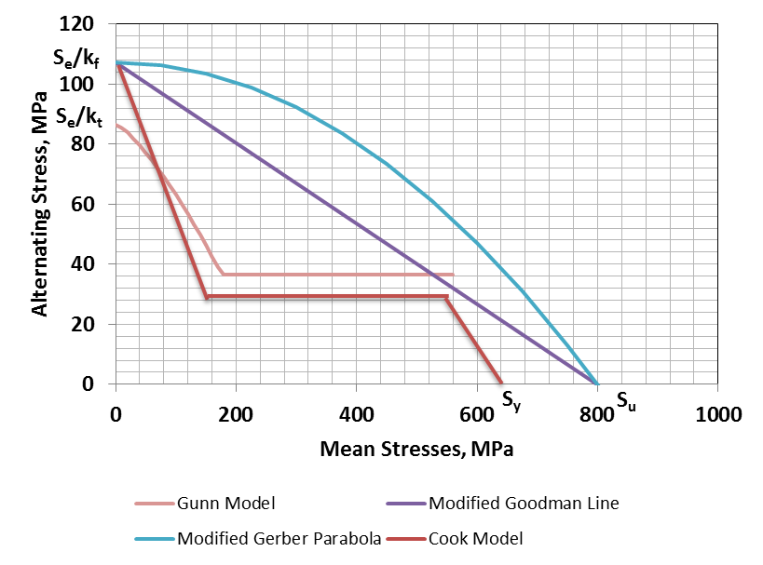

Figure 16 shows the notched fatigue models

Comparing the models above, it can be observed that the Cook model is the safest to use for design because it predicts failure at stress amplitudes much lower than the other models. Other observations are that the Cook, modified Gerber Parabola, and modified Goodman line intersects the y-axis at. The Gunn model intersects the y-axis at .

The A few of the Parameters used for formulating these models include the endurance limit (Se), the endurance limit from a Moore tensile test (Se’), ultimate tensile strength (Su), yield strength (SY), fatigue limit, notch sensitivity (q), fatigue stress reduction factor, stress area of the bolt, strain after failure, stress amplitude, elastic stress concentration factor, and the mean stress.

Se’ is the endurance limit found using the R.R. Moore rotating-beam fatigue test. Se is the modified endurance limit that takes into account the geometry, loading conditions, environment, and uncertainty of failure for a mechanical component. Surface roughness is another important factor that attribute that causes Se’ to vary from Se. A smooth surface is more resistant to fatigue caused by cyclic loading, while a rough surface can result in a lower fatigue strength and stress endurance limit.

The difference between Se and Se’ is dependent on the following empirical factors. They are the temperature factor CT, reliability factor CR, surface factor CS, gradient factor CG, and load factor CL. The fatigue factors for our mechanical component are shown in the table below:

|  |  |  |
| --- | --- | --- |
| **TABLE 1.2: Fatigue Factors applicable to the design, loading conditions, and environment of the mechanical component** | | |
| **Fatigue Factor** | **Value** | **Criteria** |
| CS | 0.77 | Machined |
| CG | 0.99 | 0.11< d<2 in |
| CT | 0.81 | T<840 F |
| CR | 0.75 | 99.9% |
| CL | 1.00 | Axial Loaded |

Using the empirical relationships which include fatigue factors, an S-N can be developed based on the conditions that our mechanical component experiences. Shown below is a graph that compares the S-N curve of the mechanical component from an R.R. Moore rotating beam fatigue test and an S-N curve empirically derived that includes the effect of fatigue factor values shown in **Table 2**:

Figure 17 compares S-N curves between a standard Moore Tensile Test and the empirically derived S-N curve that includes fatigue factors

As can be seen from the graph above, applying the fatigue factors increases the chance of fatigue failure for the mechanical component.

Stress concentration factor (Kt) shows how concentrated the stress is in a given material. It is a ratio between the maximum stress in a material and the referenced stress. Basic stress analysis assumes that the mechanical components are flawless, i.e. they are a uniform section and no irregularities. However these assumptions are not indicative of the real world. In reality, all components have irregularities and these change the stress distributions as shown in the figure below:

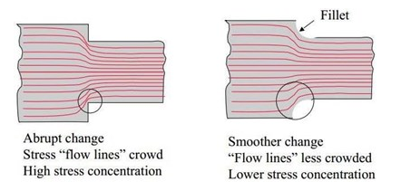

Figure 18 shows how discontinuities cause a local increase in stress [6]

There are multiple ways to approach the calculation of a safety factor. Fatigue diagrams such as the Goodman model are used for these calculations. The different ways to find safety factor are dependent on whether the alternating stress is increasing during loading, the mean stress is increasing, or both stresses are increasing during loading.

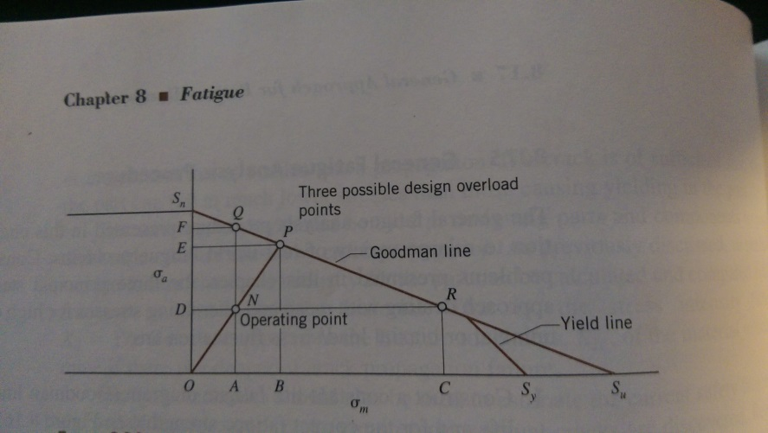

Figure 19 shows a fatigue plot using the Goodman Model

In the event of the only the alternating stress increasing, the safety factor equation is given by:

***(8)***

If the mean stress is the only component that increases during loading, the equation will be given by:

***(9)***

If both the alternating and mean stresses are increasing during loading, the safety factor will be given by the equation:

***(10)***

**1.7 References**

[1] Burguete, R.L., Patterson, E.A., “The effect of mean stress on the fatigue limit of high tensile bolts”, Proc. Inst. Mech. Engrs., 1995, vol. 209, 257-62

[2] Juvinall R.C. and Marshek M.M. 2012. *Fundamentals of Machine Component Design*. John Wiley & Sons Inc. Danvers.

[3] Bolt Science, 2013, *M16 Flanged bolt failure* , Bolt Science Limited, 29 January 2015, <http://www.boltscience.com/pages/failure2.htm>

[4] Total Materia, 2010. *Cold and Hot Forging: An Overveiw.* Total Materia, 29 January 2015, <http://keytometals.com/page.aspx?ID=CheckArticle&site=kts&NM=277>

[5] Boulons Plus, 2013. *Common Forms of Corrosion.* 29 January 2015, <http://www.boulonsplus.net/informations-techniques/corrosion-forms/>

[6] Corrosionpedia, 2015. *Stress Concentration Factor (Kt).* 29 January 2015, <http://www.corrosionpedia.com/definition/1035/stress-concentration-factor-kt>

**3.1 Team Summary and Conclusions**

Our team of engineers evaluated the mechanical component under six different loading conditions based off of six different cylinder explosion pressures. The cylinder pressures and corresponding mean and alternating stresses produced on the bolt by the explosion is shown in the table below:

|  |  |  |
| --- | --- | --- |
| **TABLE 3.1: SHOWS THE SIX DIFFERENT LOADING CONDITIONS AND THE CORRESPONDING OPERATING POINTS** | | |
| **Cylinder Pressure, KPa** | **σm Stress** | **σAlt, Mpa** |
| **6900** | **452** | **77** |
| **5800** | **440** | **64** |
| **4500** | **426** | **50** |
| **4000** | **420** | **44** |
| **3450** | **414** | **38** |
| **2720** | **406** | **30** |

The worst case stress occurs at a cylinder pressure of 6900 KPa which represents full throttle at the peak of the power curve or 9000 rpm. The lowest case stress evaluated is at a cylinder pressure of 2720 Pa which represents half throttle or 4000 rpm.

Fatigue analysis was conducted using the appropriate model for our application, the Gunn model. Fatigue modeling was based off of the value of peak alternating stress corresponding to the endurance limit at L6 cycles. Thus we are evaluating if the mechanical component can last an infinite number of cycles at the given loading conditions. The fatigue model is shown below and includes all the operating points described in the table above:

Figure 20 Shows the Gunn fatigue model and the operating points of the six loading conditions

The figure above shows that all of the operating points fall below the Gunn fatigue line. This suggests that the mechanical component will never fail at any of the indicated loading conditions. To account for uncertainties in loading, safety factors will be evaluated at each operating condition. For our application, we will assume a safety factor of 1.25 or greater is acceptable for our mechanical component. The graph below shows the methodology used to calculate the safety factors at each different loading condition:

Figure 21 shows the methodology used to calculate the safety factors

The definition of safety factor according to the above figure is the following:

**(8)**

Where Rx is the distance from the origin to one of the operating points, e.g. R6900 represents the distance from the origin to operating point corresponding to the loading condition at 6900 kPa. The safety factor was determined with the following methodology:

a) A trend line was placed through the operating points and the intersection between the Gunn fatigue line and the trend line was determined. The equation of the trend line going through the operating points is given in the equation below:

**(9)**

R1 was determined by first locating the endpoint that corresponds to the intersection of the Gunn model and the trend line through the loading condition operating points. Pythagoras theorem was used to calculate R1 and Rx. The equation is given below:

**(10)**

b) Then the safety factor was determined with **eqn. 8**.

The intersection between the regressed line and the Gunn model was determined to be at the coordinate (484 MPa, 108 MPa). The safety factors for each loading condition are described in the figure below:

Figure 22 shows the safety factors corresponding to the different loading conditions

As can be seen by the above graph, each loading condition has a S.F. >1 which suggests that the mechanical component will not fail. In conclusion, the head bolt is well designed for its application.

In this project we learned how to analyze fasteners as well as develop an understanding for the concept of fatigue. We learned that the Gunn model is most appropriate for analyzing bolts placed under a high tensile stresses. We also learned how to work better as a team going forward.

Next time we will function better as a team and be wiser in picking are mechanical component that way we can invest our time more wisely and produce a better product at the end.

**Section 3.2 TEAM Contributions**

For the team portion of the report, the work was evenly distributed into groups of two. From the beginning of the report, Caleb and Stephen evenly contributed to Section 1.1. Brandon and Gatlin equally contributed to Section 1.2. Adam and Brian both split the work evenly for Section 1.3 and Section 1.4. Brandon and Caleb equally contributed to the work for Section 1.5. The final portion of the team report, Section 1.6, was split between Gatlin and Stephen. Section 3 was completed by Brandon.

**3.3 Team Level of Effort**

|  |  |
| --- | --- |
| **TABLE 3.2: TIME SPEND WORKING ON THE PROJECT** | |
| **Member** | **Hours** |
| Gatlin Arnold | 42 |
| Caleb Berryman | 42 |
| Brandon Tolbert | 55 |
| Adam Wagner | 20 |
| Stephen Walta | 42 |
| Brian Wanezek | 20 |
| *Total* | *221* |